Audience Award
Montreal World Film Festival 07

Best First Documentary
Doclisboa 07

Best German Documentary
DOK Leipzig 07

Jury Special Nomination Award
Docaviv 08

Best Directing
Krakau Film festival 08

Jury Special Award
Jecheon Music film festival 08

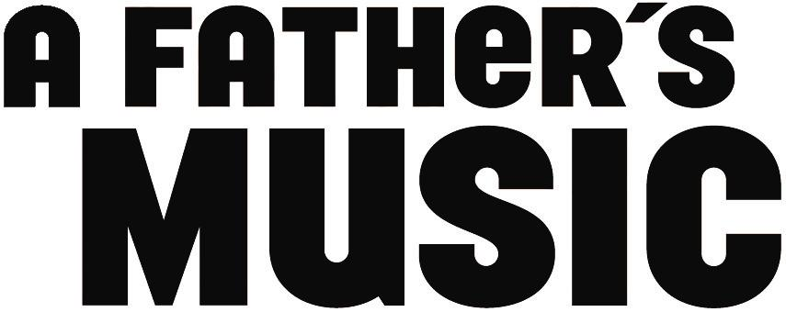

A Documentary Feature Film by Igor Heitzmann

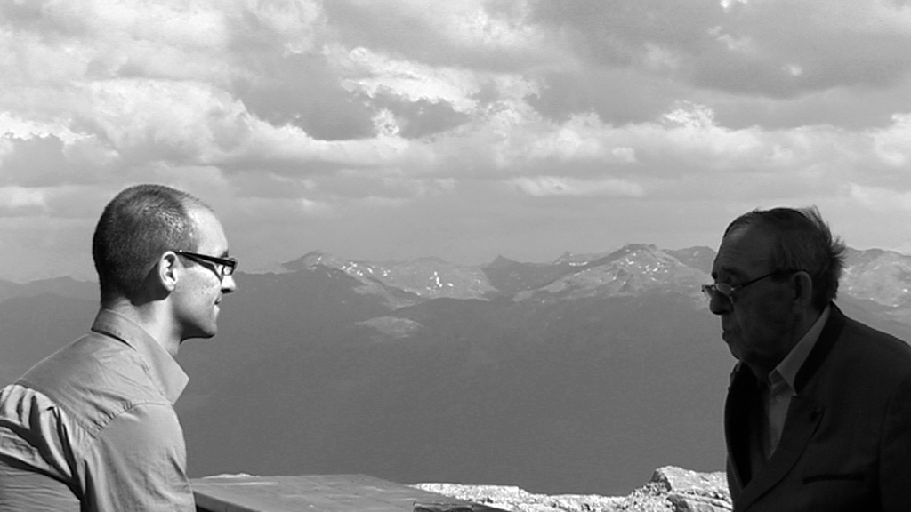

Producer Director
Filmkombinat GmbH & Co. KG Igor Heitzmann
Franz-Mehring-Platz 1 Arndtstr. 32
D-10243 Berlin, Germany D-10965 Berlin, Germany
Tel.: +49.30.27 90 88 38 Tel.: +49.30.69 50 59 95
Fax: +49.30.27 90 88 39 Fax: +49.30.257 59 162
Email: jens.koerner@filmkombinat.de Mobile: +49.179.202 55 84
Internet: www.filmkombinat.de Email: donigor@gmx.net

Photos & info: www.nachdermusik.de/en
SHORT SYNOPSIS

Famed Austrian conductor Otmar Suitner's affair with a much younger woman resulted in a divided life - he had two different families separated by the Berlin Wall. When Suitner's grown son rediscovers and reclaims his father's past - including rare footage of his performances - secrets are uncovered and startling new memories created.

FULL SYNOPSIS

Shortly after the Wall came down, the Austrian conductor Otmar Suitner ended his long-standing career at the State Opera in East Berlin. Parkinson syndrome was causing his hands to tremble. A conductor who had achieved world fame at Bayreuth could not control the baton. Music disappeared from his daily life. But the fall of the Wall brought something new: changes to his family life. For decades Suitner had two private lives, one with his wife in East Berlin, the other one with his mistress and their son, Igor, in the west of the divided city.

In A Father's Music Igor Heitzmann tells the story of a rapprochement: with his father, the distant conductor; with a vanished country, the German Democratic Republic; with the exceptional paths of his parents’ lives; and with music. He shows the great moments of Suitner's life as a musician, celebrated concerts and concert tours, but also common orchestra rehearsals or the work with students of the conductor's class at the University of Music in Vienna. Through the music recordings Igor Heitzmann's own, fragmented memories of his rare encounters with the father are tied together. He reconstructs the family story between East and West through interviews, archive footage, and original scenes.

A Father's Music is the portrait of a man whose life was an incredible balancing act - between communism and the West, private life and career, wife and mistress - and, above all, he always lived for music. A film about a great conductor, told by his son who seeks out music in order to find his father.
DIRECTOR'S STATEMENT

In making my film, A Father’s Music, I set out on a journey to get to know my father, the conductor Otmar Suitner.

When he turned 80 in 2002, I realized that our time together was running out. I knew if I wanted to get closer to him, I would have to film him. As a conductor, he needs music to express his feelings, as a filmmaker, I need a camera.

The challenge was to find a cinematic form that would be appropriate for the complex texture of our fragmented memories. The film’s three strands, the portrait of a musician, the story of a family, and the chronicle of contemporary history, needed to weave together in a sensual way, like the various themes of a symphony. Once the filming was under way, it became more and more clear that A Father's Music would also be the chronicle of a farewell between a father and his son.

It was my greatest wish to see my father conduct again. When I last saw him perform, I was too young to appreciate it. For me and for my film, my father agreed to return to his conductor’s stand one last time – and he was able to throw off the chains of old age for a short while. Through the film, a new powerful and permanent memory was created.

Igor Heitzmann, April 2007
BIOGRAPHY & FILMOGRAPHY
IGOR HEITZMANN (DIRECTOR)

born in Rendsburg, New Years Eve 1971
raised & currently living in Berlin

1995 - 2006 film studies at the German Film and Television Academy, Berlin (DFFB).

1995 Orson Welles – The One-Man Band, assistant director
feature-length documentary (director: Vassili Silovic).

1993 – 1995 assistant director, script editor, translator, production assistant.

1992 – 1993 Theatre Studies, Freie Universitaet Berlin

1991 – 1992 A-Levels. “Film year” in Paris.

1981 – 1991 piano studies.

FILMS (WRITER/DIRECTOR):

A FATHER’S MUSIC, 2007, Digital Betacam/35 mm, 105 mins
Documentary feature film

RUNAWAY, 2002, 35 mm, 15 mins
Short fiction film

FAMILY, 2000, Digital Betacam, 16 mins
Short fiction film

LA PETITE MORT, 1998, 16 mm, 8 mins
Short fiction film

ANTHROPOPHOBIA, 1997, 16 mm, 8 mins
Short fiction film

INSANITY INCREASING, 1996, Betacam, 2 mins
Experimental short film

SHORT BIOGRAPHY OTMAR SUITNER (PROTAGONIST)

Otmar Suitner was born on May 16, 1922, in Innsbruck, Austria. He completed his music studies (piano, conducting) at the Mozarteum in Salzburg in 1942, and began his career as a pianist. After engagements as a conductor in Remscheid and Ludwigshafen-Mannheim, he became General Music Director of the Dresden State Opera in 1960. In 1964, he moved to the Berlin State Opera, where he remained the director until 1990. In addition, he was head of the conductor's class at the music university in Vienna, and gave guest performances with the Berlin State Orchestra around the world.

Otmar Suitner was guest conductor at the Bayreuth Wagner Festival (1964-1967), and of numerous orchestras, including the NHK Symphony Orchestra in Tokyo, the San Francisco Opera, the London Symphony Orchestra, and the Munich Philharmonic Orchestra. He collaborated with soloists such as David Oistrakh, Artur Rubinstein, Alfred Brendel, Emil Gilels and Radu Lupu. Suitner conducted countless opera performances, his main focus being Wagner, Strauss and Mozart. But he was equally eager to conduct world premieres of new operas from contemporary composers, such as Paul Dessau. In 1994, at the age of 72, Suitner conducted for the last time in Göteborg, before retiring for health reasons.

A FATHER'S MUSIC

A critical element in the making of A Father’s Music was the search in archives around the world for television, film, and audio recordings of Suitner’s concerts. Thanks to these recordings, many of which have not been available to the public for some time, I was able to trace my father’s professional path, and to observe his development over the decades. Many of the performances are live recordings, in contrast to his numerous studio recordings, which are available on CD. The following is a list of the most important film and audio recordings, in order of their appearance in the film:

Johannes Brahms: Symphony No. 1 in C minor, Op. 68, Staatskapelle Berlin (1985)

Maurice Ravel: La Valse (Poème choréographique for orchestra), Rundfunk-Sinfonieorchester Leipzig (´57)

W.A. Mozart: Symphony Nr. 39, in E flat major, KV 543, 2nd movement: Andante con moto, Staatskapelle Dresden (1976)

Max Reger: "Variationen und Fuge über ein Thema von Mozart", Staatskapelle Berlin (1965)

Richard Wagner: Tristan und Isolde, l'Orchestra Sinfonica di Torino della Rai (1984)

Johann Strauß: Die Fledermaus, overture, Staatskapelle Berlin (rehearsal, 1975)

W.A. Mozart: Così Fan Tutte, overture, Deutsche Staatsoper Berlin (1966)

Paul Dessau: "Symphonische Adaptationen des Quintetts Es-Dur, KV 614, von W.A. Mozart",
DWV 346, Staatskapelle Berlin (1970)

W.A. Mozart: Concert for Violin and Orchestra No. 5 in A major, KV 219, David Oistrakh (violin),
Staatskapelle Berlin (1966)

Giaocchino Rossini: Il barbiere di Siviglia, Deutsche Staatsoper Berlin (1971)

Ludwig van Beethoven: Symphony No. 3 in E flat major, Op. 55 „Eroica“, NHK Symphony Orchestra (1988)

Franz Schubert: Symphony in C major Op. posthum., Staatskapelle Berlin (1978)

Ludwig van Beethoven: Symphony No. 5, Op. 67, C minor, Staatskapelle Berlin (1982)

Suitner conducts the Staatskapelle Berlin in a concert especially for the film, following a nine-year absence from the podium. We hear excerpts of the following pieces:

W.A. Mozart: Symphony No 39, E flat major, KV 543, Staatskapelle Berlin

Josef Strauss: "Die Libelle", Polka Mazur, Op. 204, Staatskapelle Berlin.

Franz Schubert: "Ballett- & Zwischenaktmusik aus Rosamunde", D 797, Staatskapelle Berlin
FESTIVALS

Visions du Réel, Nyon, 2007
Documenta Madrid, 2007
Montreal World Film Festival, 2007
Vancouver International Film Festival, 2007
Docúpolis, Barcelona, 2007
Doclisboa, Lisbon, 2007
DOK Leipzig, 2007
Kino! 2007 at the Museum of Modern Art, New York, 2007
Magnificent 7, Belgrade, 2008
Big Sky Documentary Film Festival, Montana, USA, 2008
Sofia International Film Festival, Bulgaria, 2008
It’s All True, Brazil, 2008
DocAviv, Israel, 2008
EDOC 7 - Encuentros del Otro Cine, Ecuador, 2008
Krakow Film Festival, Poland, 2008
Moscow International Film Festival, Russia, 2008
Dokufest - Int. Documentary and Short Film Festival, Prizren, Kosovo, 2008
Jecheon International Music & Film Festival, South Korea, 2008
AsoloArt Film Festival, Asolo, Italy, 2008
Unerhört! Music Film Festival Hamburg, Germany, 2008
Wismar Film Festival, Germany, 2008
Soundtrack Cologne, Germany, 2008
Vilnius Documentary Film Festival, Lithuania, 2008
Kino – Festival of German Films, Lisbon, 2009
Festival Ciné Scène, Evreux, France, 2009

AWARDS

Public Award for Best Documentary - Montreal World Film Festival
Prize Adobe for Best First Documentary - Doclisboa
Zweitausendeins Award for the Best German Documentary - Dok Leipzig
Special Jury Nomination Award - Docaviv
Silver Horn for Best Directing - Krakow Film Festival
Jury Special Award – Jecheon International Music & Film Festival

PRODUCTION INFORMATION

This feature-length film debut is a co-production between DFFB – Deutsche Film- und Fernsehakademie Berlin (German Film and TV academy Berlin), ZDF – Das kleine Fernsehspiel (commissioning editor: Claudia Tronnier), Filmkombinat Nordost GmbH (executive producer) and Igor Heitzmann (director/co-producer).

Filmkombinat Nordost executive producer
Mr. Jens Körner
Franz-Mehring-Platz 1
10243 Berlin GERMANY
jens.koerner@filmkombinat.de
www.filmkombinat.de
phone: +49-30-27 90 88 38
fax: +49-30-27 90 88 39

Igor Heitzmann director & co-producer
Arndtstr. 32
10965 Berlin, GERMANY
donigor@gmx.net
phone: +49-30 - 695 05 995
fax: +49-30-257 59 162

German Film & Television co-producer
Academy, Berlin (DFFB)
Ms. Jana Wolff
Potsdamer Str. 2
10785 Berlin, GERMANY
wolff@dffb.de
www.dffb.de
phone: +49 - 30 - 257 59 - 152
fax: +49 - 30 - 257 59 -162

ZDF – Das kleine Fernsehspiel co-producer
Ms. Claudia Tronnier commissioning editor
ZDF-Straße
55100 Mainz, GERMANY
tronnier.c@zdf.de
phone: +49-6131-70-4911
TECHNICAL DATA

Original title: Nach der Musik
English title: A Father’s Music
Genre: documentary feature film
Running time: 105 minutes
Film process: 35mm (transfer from Digital Betacam)
Screen ratio: 1 : 1.85
colour & black-and white
Frames/sec.: 25
Length: 2992 m
Number of reels: 7
Sound: Optical, Dolby Digital SRD (5.1)
Language: German
Subtitles: English
Country of origin: Germany
Year of production: 2007

FULL CAST & CREDIT LIST

Featuring
Otmar Suitner, Marita Suitner, Renate Heitzmann & Igor Heitzmann

And the generous participation of
Staatskapelle Berlin

Written & directed by
Igor Heitzmann

Edited by
Inge Schneider

Directors of Photography
Rali Raltchev, Hoyte van Hoytema

Camera Assistant
Markus Otto

Sound Engineers
Ulla Kösterke, Ivonne Gärber

Sound Designer
Daniel Iribarren

Sound Mixer
Martin Steyer

Production Manager
Ivette Löcker

Script Consultants
Claudia Tronnier, Stefan Schwietert

Assistant Directors
Reinhild Blaschke, Ivette Löcker

Additional Editing
Frank Brummundt, Karin Nowarra

Archive Research
Reinhild Blaschke, Ivette Löcker, Kirsten Lenk

Producers
Jens Körner, Oliver Niemeier, Thomas Riedel

Commissioning Editor
Claudia Tronnier

Line Producer dffb
Anja Firmenich

Compositing
Francesco Sacco Multimedia

Title Design & Artwork
Katja Clos

Colour Matching
Vera Jeske

Cameramen (Concert Sequence)
Frank Amann, Marcus Lenz, Markus Otto

Additional Camera
Marcus Lenz, Lutz Reitemeier

Second Assistant Camera
Benjamin Raeder

Grip (Concert Sequence)
Ulf Binder

Sound Engineer (Bayreuth Sequence)
Andreas Köppen

Additional Sound Engineer
Peter Carstens

Production Assistants
Clarissa Thieme, Patrizia Monzani, Imke Scholvin-Watts

Assistant Editors
Cecilia Kramer, Stephan Wagner, Stefanie Winzer, Katja Reinhardt, Lea Römer

Interns
Mania Huppertz, Dorit Selzer, Oliver Berger

A production of
Filmkombinat Nordost Gmbh & Co KG

In co-production with
ZDF - Das kleine Fernsehspiel / The German Film and Television Academy Berlin (dffb) /
Igor Heitzmann

Funded by
Filmförderungsanstalt (FFA) / Kulturelle Filmförderung Mecklenburg-Vorpommern /
Land Tirol / Stadt Innsbruck / German Films

